# Freedom from stock UI elements

Table of Contents

Freedom from stock UI elements 1

1. Screen resolutions 1

a. 1920 x 1080 1

b. 1366 x 768 2

c. 1024 x 768 2

2. Features 3

a. Click on each city to show its info underneath 3

b. Close application by clicking on “X” icon (top left) or pressing “Esc” key 3

c. Scalable 3

# Screen resolutions

## 1920 x 1080

## 1366 x 768

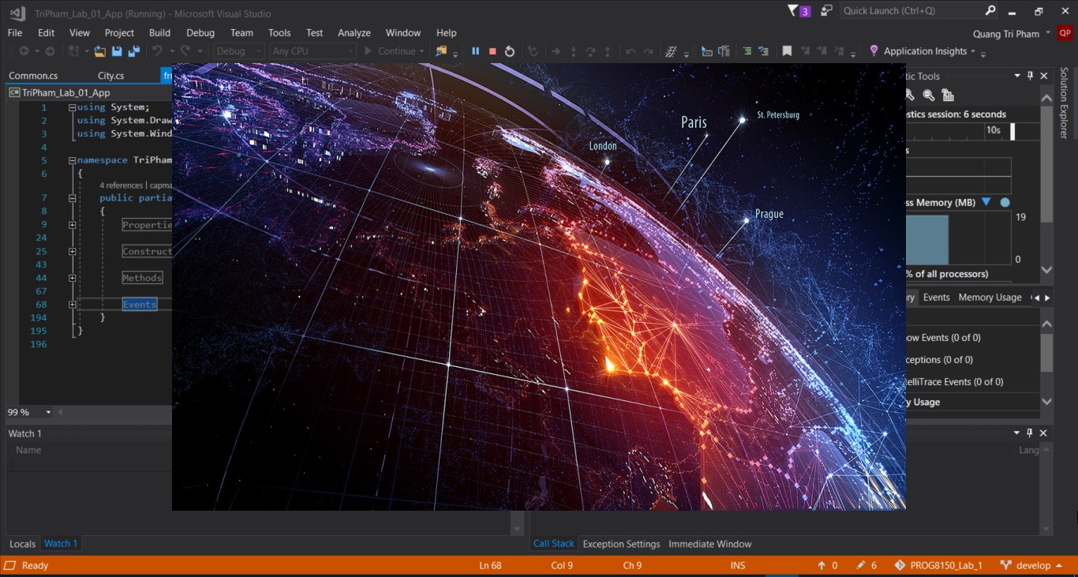

## 1024 x 768

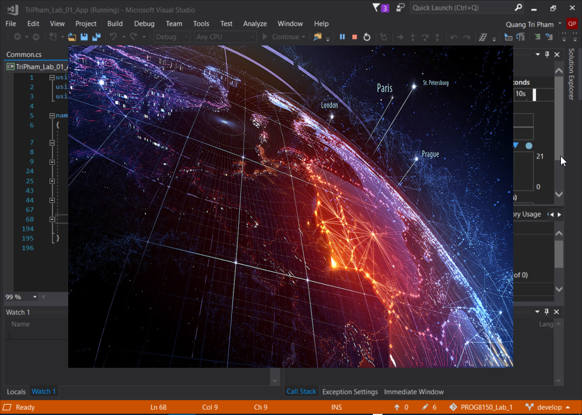

# Features

## Click on each city to show its info underneath

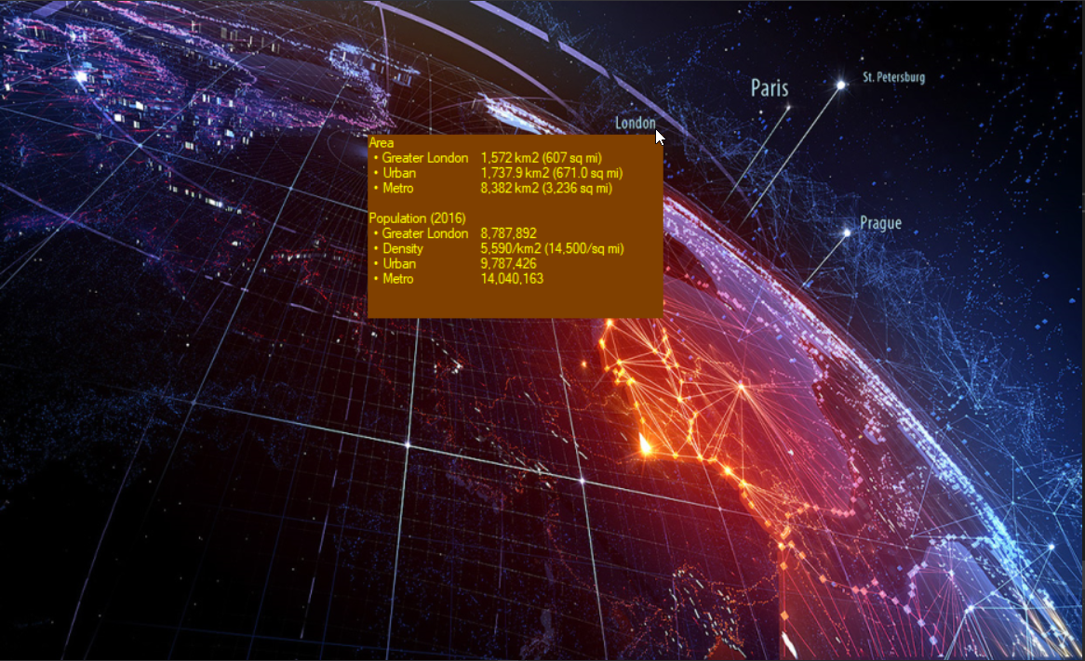

## 

## Close application by clicking on “X” icon (top left) or pressing “Esc” key

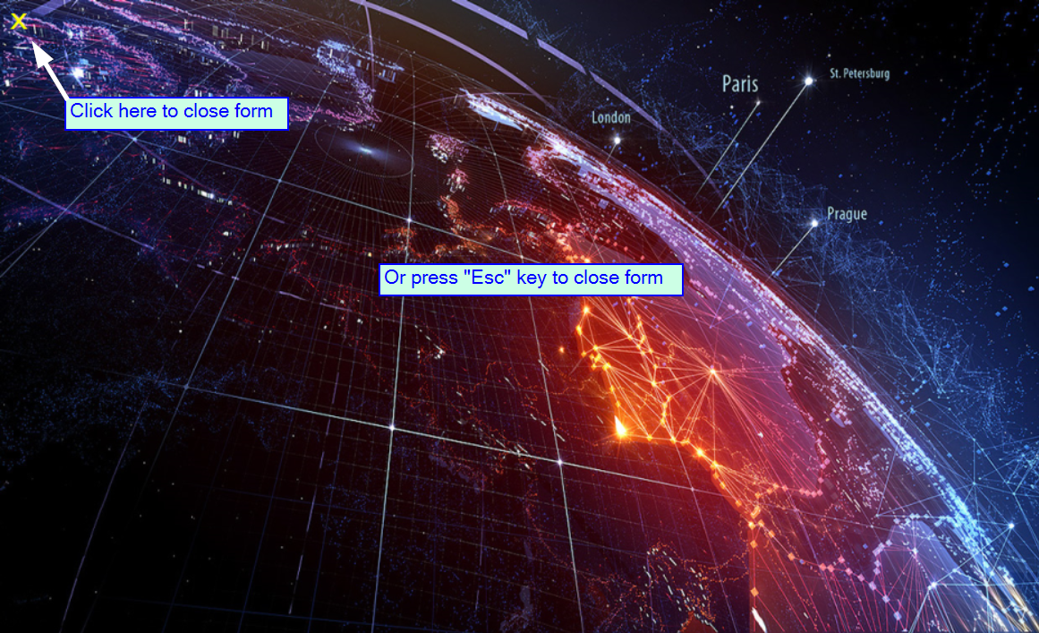

## Form resizable

Click at the right bottom of the application and hold then drag to resize the window

